Artifakt 5. Návrh doménového systému Matyáš Daňa

Sequence diagrams

UseCase1:

UseCase2: 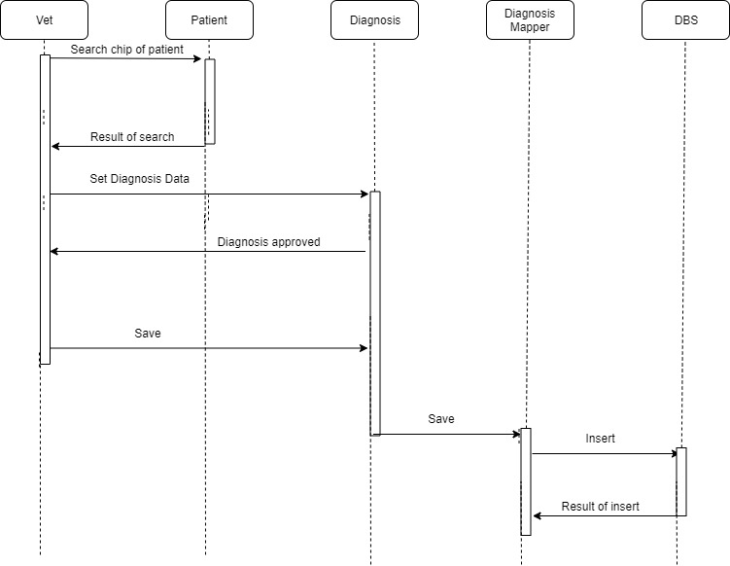

UseCase3:

Development models:

1. Domain model

2. Data Mapper

3. Data Transfer Object

4. Identity Field

5. Foreign Key Mapping